EXPOSYS DATA LABS

PROJECT REPORT ON

“CUSTOMER SEGMENTATION”

DATA SCIENCE PROJECT

Submitted by – Aaryan Trivedi

## ACKNOWLEDGEMENTS

**We,** take this opportunity to thank one and all involved in helping us build this project. Firstly, we would like to thank the college for providing us an opportunity to work on this project.

We thank the management of **EXPOSYS DATA LABS** for providing all the resources required for the project.

We wish to acknowledge my sincere gratitude to their faculties for their constant encouragement and for providing us with all the facilities required for the accomplishment of this project.

We also, are highly grateful to the guidance offered By staff memberswho have been very generous in assisting and supporting, to do this project named **“CUSTOMER SEGMENTATION”**, which formally started as just a rough idea and now has resulted in the form of this project.

We also would like to thank all the other teaching and non-teaching staff members who had extended their hand for support and co-operation while bringing up this project.

|  |  |
| --- | --- |
|  |  |
| **AARYAN TRIVEDI** | **(1JS19EC002)** |

ABSTRACT

Customer segmentation is an effective tool for businesses to closely align their strategy and tactics with, and better target, their customers. Every customer is different and every customer journey is different so a single approach often isn’t going to work for all. This is where customer segmentation becomes a valuable process. Let’s begin with understanding exactly what customer segmentation is

Customer segmentation is the process by which you divide your customers up based on common characteristics – such as demographics or behaviours, so you can market to those customers more effectively.

These customer segmentation groups can also be used to begin discussions of building a marketing persona. This is because customer segmentation is typically used to inform a brand’s messaging, positioning and to improve how a business sells – so marketing personas need to be closely aligned to those customer segments in order to be effective.

The marketing “persona” is by definition a personification of a customer segment, and it is not uncommon for businesses to create several personas to match their different customer segments.

But for that to happen, a business needs a robust set of customer segments off of which to base it. Which leads us to the next section, distinguishing the difference between customer segmentation and market segmentation, so that your segmentation is as accurate as possible.

CODE SNIPPET

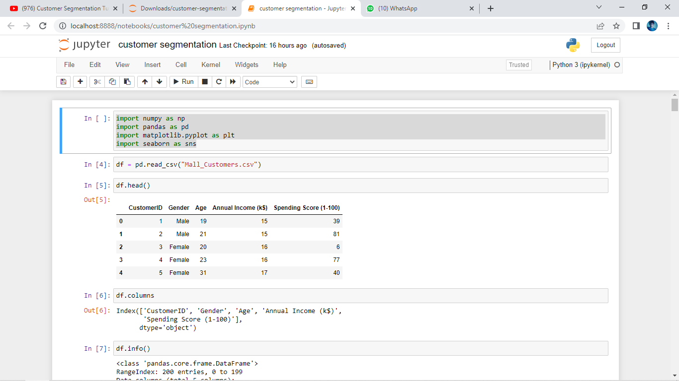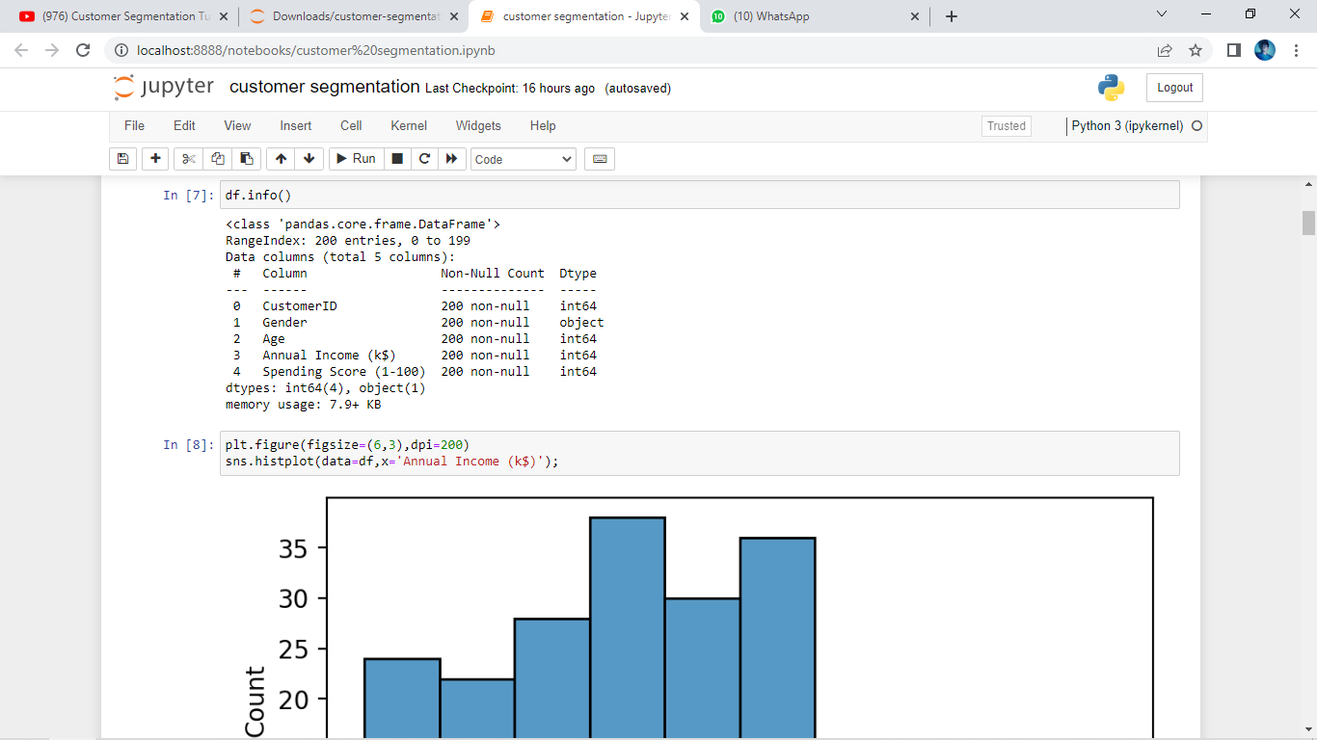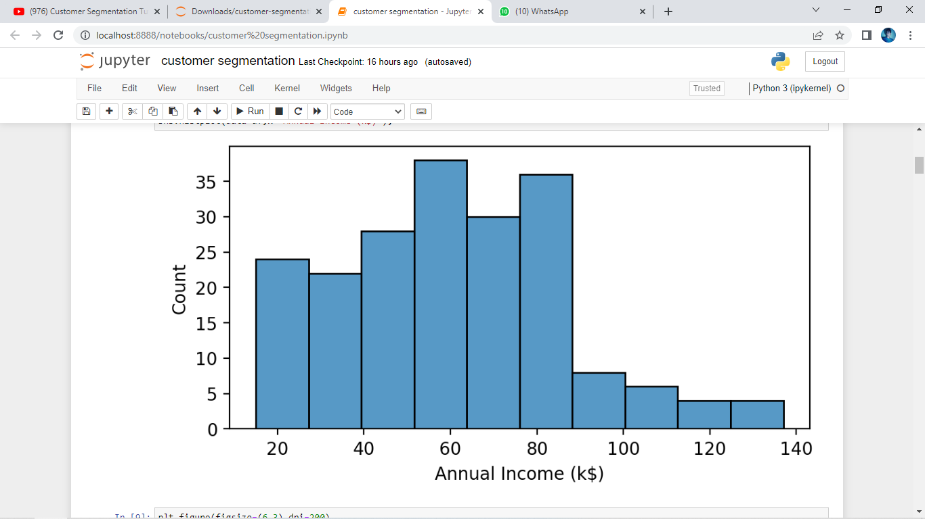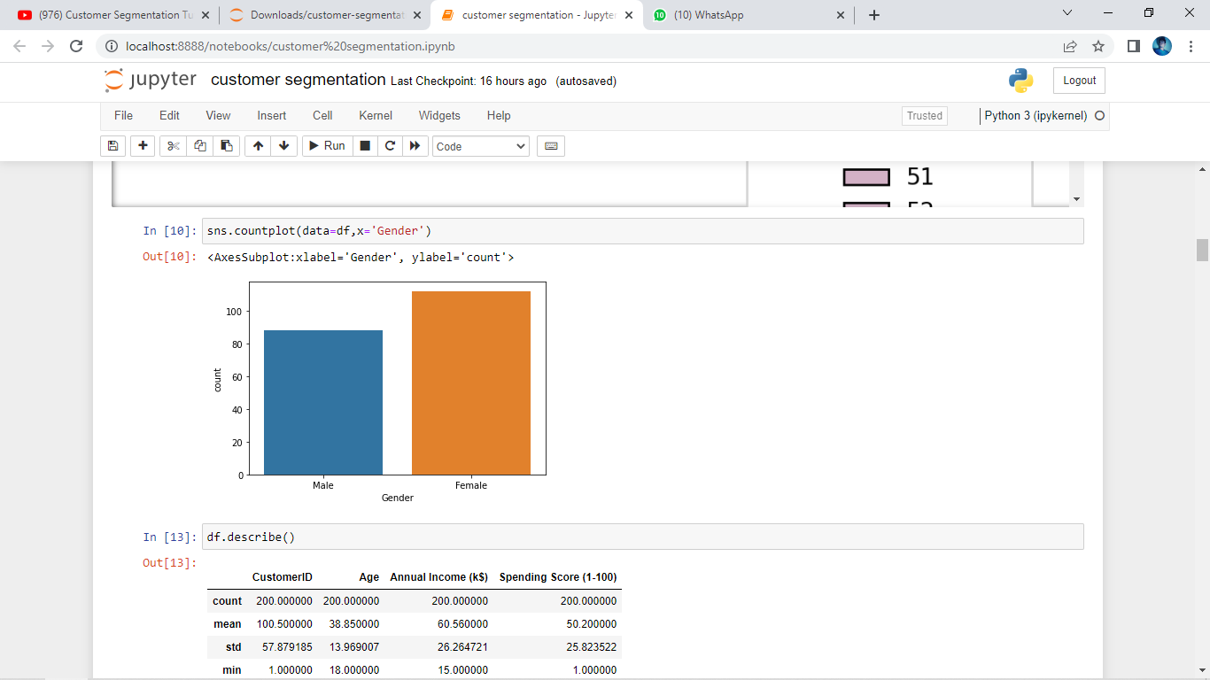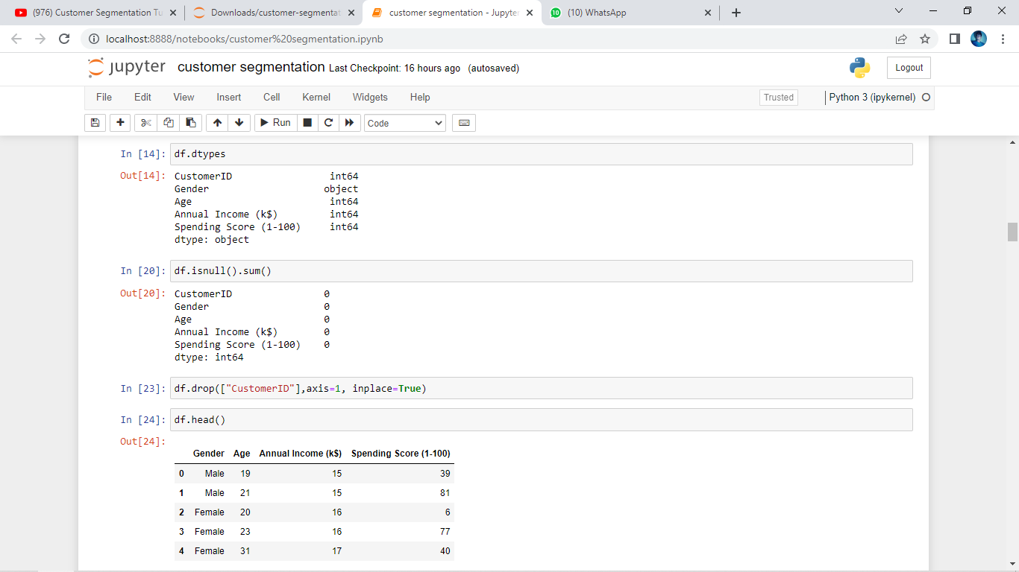C